
COLLEGE
ADMISSIONS: WHAT

ACTUALLY MATTERS

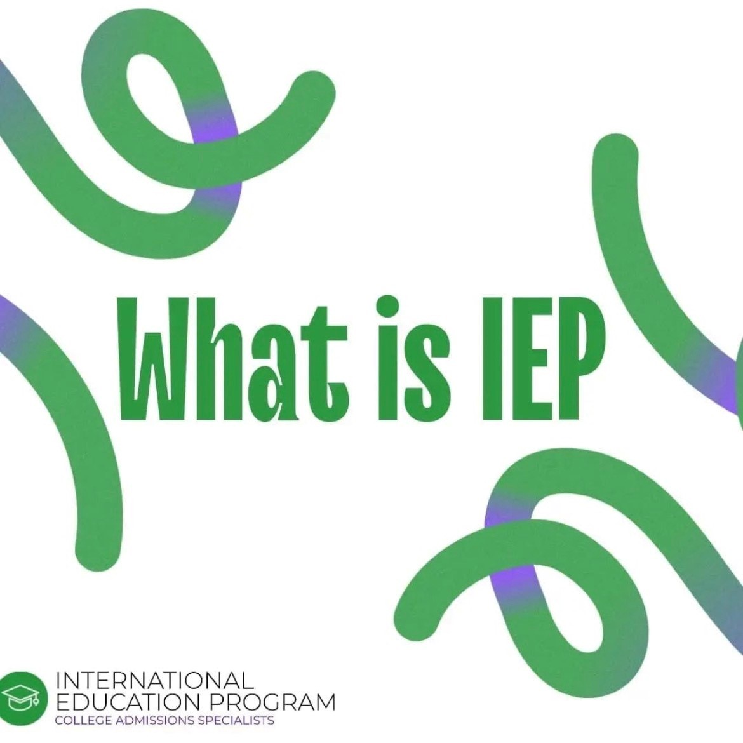
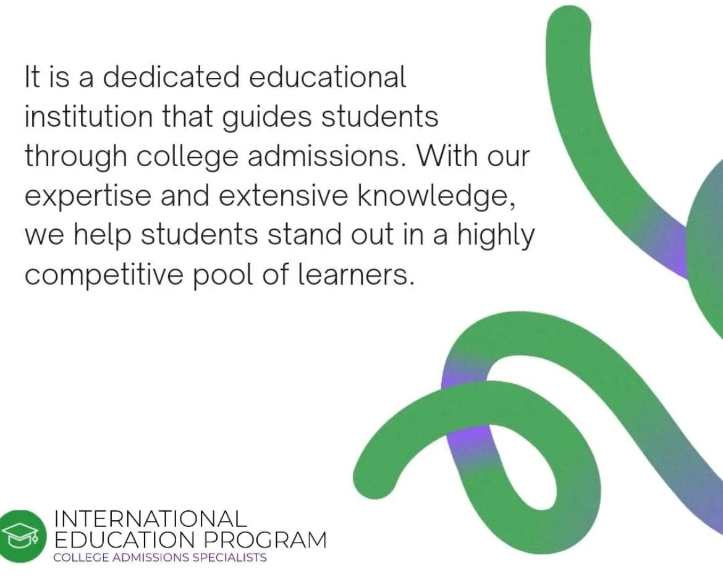


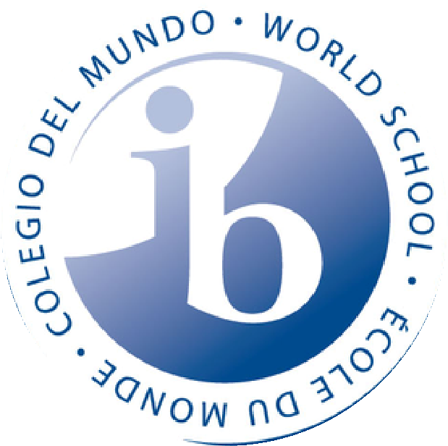


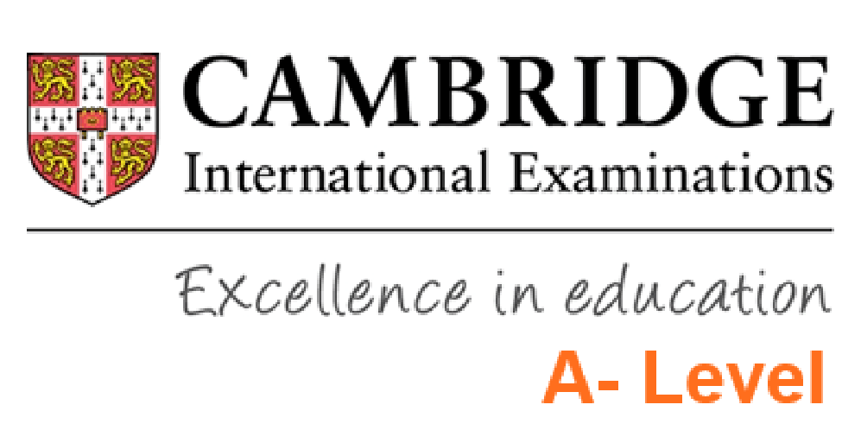
Choosing the Right School System
School system choice depends on your preferred style of learning. Every system has their own way of teaching and learning and as long as it’s aligned with your most effective style of learning, universities will accept it. Universities don’t prefer one qualification over the other. But your grades do matter and you’ll only perform your best academically if the learning environment is right for you.
Page 01


Strengths of Each System
Academic rigor,
research skills _{IGCSE} Subject depth IB _{A-Levels}
GPA + course
College Credit,
rigor American AP Flexibility
Diploma
Page 02


Extracurriculars
The number of EC’s don’t matter. It is what you’ve achieved in them and how you can showcase your passion for it. You can do one thing e.g debates and if you’ve made it to the international level, it will be more effective than 5 EC’s where you haven’t achieved much.
Page 03

Why ECS matter
They show interest, commitment, and impact.
Why do they matter?
Page 04

Smart EC Selection
Bas
ed on passion & interests
Related to intended major
Opportunities for leadership
Ec selection
Page 05

The Ideal Range
01
02

EC Quantity vs Quality
5-8 meaningful activities
Depth matters more than count
Leadership > participation
Common EC Mistakes
Too many shallow activities
Short-term involvement
Resume padding
Page 06


Is volunteering required?
Volunteer is important. Number of hours don’t matter. Consistency matters more. For example if you have been volunteering throughout the year for a few hours a week. That would mean more than volunteering just in the summer. Also within the volunteer work it matters what you’ve done. For example if you have lesser hours but you’ve contributed something significant, that would hold more value than doing more hours.
Page 07
Planning Your Application
Start early
Research requirements
Build a balanced college list
Meet deadlines
Polished essays
Accurate activity descriptions
Page 05

Ivy League Admissions
02
01
03
Academic excellence  Intellectual curiosity  Campus contribution | Harvard: leadership + impact  Brown: curiosity + independence  Princeton: academics + research | Fit matters  Story matters  Authenticity wins
Page 11
What Makes You

Memorable

Well and clearly w
ritten
essay
Strong and deep letters of
recommendation
Strong and rigorous
academics
Voice and personality

Clear direction, personal
growth
Leadership qualities
demonstrated through an
activity or initiative

Page 12

FINAL ADVICE
START EARLY
BE INTENTIONAL
BUILD YOUR STORY

